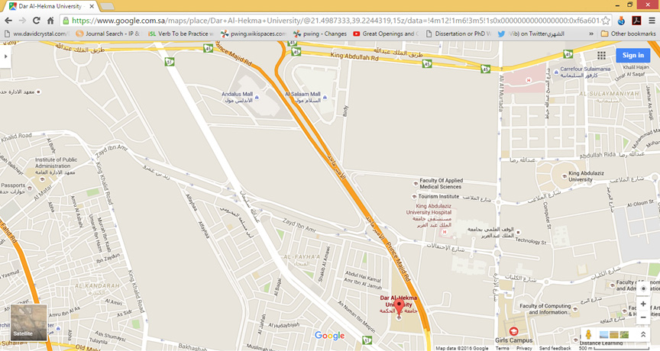
https://www.google.com.sa/maps/place/Dar+Al-Hekma+University/@21.4910467,39.2387227,14z/data=!4m12!1m6!3m5!1s0x0000000000000000:0xf6a601a73cc36b1f!2sGirls+Campus!8m2!3d21.4875515!4d39.2407978!3m4!1s0x0000000000000000:0xd5e69863dbf5f7fa!8m2!3d21.4886926!4d39.2305684

