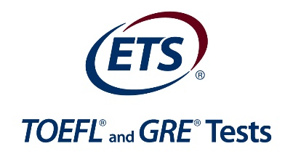

TOEFL Training at the KSAALT @ 10 Conference with KSAALT TESOL
Again this year, there is the chance for 30 conference delegates to sign up for TOEFL training.
Sponsored by ETS, and delivered by Brent Corley at Amideast, you will be able to attend the opening of the conference and the final plenary speakers' addresses.

About Brent Corley:
Brent Corley is the Testing Manager for AMIDEAST Saudi Arabia. For more than 10 years he was worked as a consultant and facilitator in both business and education.
He has many years of experience with teaching English as a second language from elementary to university level. In addition to his undergraduate in health education, he has earned graduate degrees in Business Administration and Public Health. Brent says he enjoys being a PROPRELL® facilitator because “the workshops are not only powerful, relevant, and engaging – they’re also easy and fun to deliver.”
The Propel® workshop is a one-day professional development program designed to help English-language teachers meet the challenges of teaching English to students. The workshop uses examples from the Reading, Listening, Speaking and Writing sections of the TOEFL iBT® test. It provides instructional techniques and strategies for using the integrated-skills approach to teaching language and for preparing students for success.

Details about registration
Once you are registered for the conference and have paid the appropriate conference fee, your application to attend this workshop will be processed.
The training will cover about Run from 09:00 until 4:00pm. There will be a break for trainees to join the conference for lunch.
Please fill in the registration document for this training here. Places will be offered on a first come first-served process if you have registered and paid your conference fee.

1. TOEFL Participant’s Information
Name Badge and Personal Information
Title: | First Name: | Surname:
Cell Phone:
E-mail:
Registered & Paid for Conference? | Yes/No

N.B. Participants will receive a certificate upon completion of the workshop, but receipt of the certificate will require that you’re present for the full workshop event.

For Office use Only:
(delete inapplicable choice)
Delegate has Chosen IELTS/TOEFL:
Registered and Paid for Conference: Yes/No
Further action and notes:

