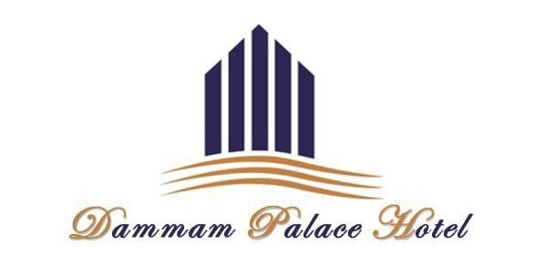
KSAALT TESOL Annual Conference
May 5 & 6, 2017
Interserve Learning and Employment
(Formerly ESG College)

May 5, Friday
Coffee Break
Homemade Cookies / Homemade English Cake/ Canapés
Tea & Freshly Brewed Coffee
Mineral Water/ Assorted Juice

May 6, Saturday
Breakfast
Homemade Cookies / Croissant / English Cake
Tea & Freshly Brewed Coffee
Mineral Water/ Assorted Juice

Lunch Buffet
Salads
Mutable, Fattoush, Hummus, Pickles, Tomatoes, Caesar Salad
Selection of Bread

Main course
Beef with Mushroom Sauce
Roasted Chicken
Grilled Fish with Lemon Butter Sauce Pasta with White Sauce Oriental Rice
Sautéed Vegetable

Dessert
Black Forest Cake
Fruit Salad

