TENTH KSAALT ANNUAL CONFERENCE, MAY 5-6, 2017
Suggested Hotel:
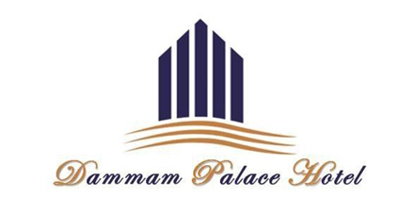
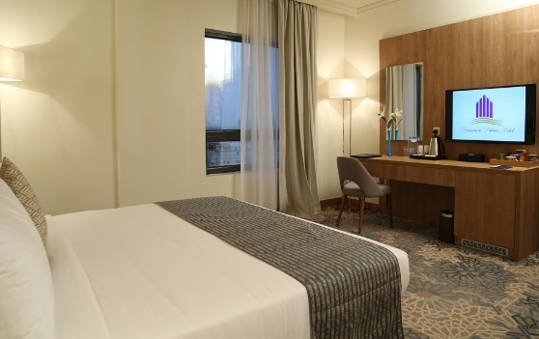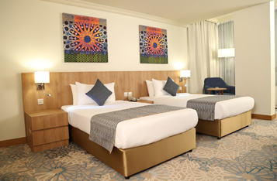
Rooms

ROOM TYPE | CORPORATE RATE (SAR/PERSON)
Single Room with Breakfast | 380
Double Room with Breakfast | 430

Transportation (Exclusive)

ROUTES | RATE
Dammam to Bahrain | 375
Dammam to Causeway | 100
Dammam to Airport | 100

NOTE: Anyone who wishes to stay at this hotel - make a reservation at Info@dammampalacehotel.com
You must also send your name to Malikah Sisay at msisay@pmu.edu . Transportation to Interserve Learning and Employment Group (ILE) (formerly ESG) is provided free to ONLY those staying at the hotel.
www.dammampalacehotel.com
T: +966 13 805 6060 F: +966 13 805 6385
PO Box 1591, Dammam, 31441, Kingdom of Saudi Arabia

